How Flood has affected Indian Economy and How Insurers can use this Flood Data

India is a leading and developing country with sharp economic growth. After the outbreak of Covid-19, all the countries across the Globe faced a downfall in their Economy. After 2020 India’s GDP shrank 7.3% and the GDP growth crashed by 23.9 %, it was only after the mid of 2021 that India had seen a ray of hope and the economy had stabilized and was heading towards a greater Future. India Bounced back in the year 2022 when the GDP increased and it retained its spot with a GDP of 3250.078 Billion US Dollars and a PPP of 10.22 Trillion US Dollars.

* **Was Covid-19 the only reason for the decline in the Economy?**

Another major cause of the decline in the economy is Natural Disasters. In which the most frequent ones are floods. India is said to be one of the most flood-prone countries in the world with an average of 1650 people losing their lives between the years 1953-2016. Let us consider a dataset for the year 2016-2018, which will help us showcase how many losses have been accounted for due to Flood between these years concerning Damages to crops, Damages to houses, and Damages to the public, and utilities. This Data which was available on **Open Government Data (OGD)** Platform will help us analyze the situation and help us understand which the most affected areas/states are across India due to Flood. We will be using some of the basic tools such as **Power Bi** and **Jupyter Notebook** for visualization of data to better understand this data.

* **How can this data be useful?**

The present study examines how economical losses have been incurred due to Flood between the years 2016-2018. The dataset focuses on the losses of crops, houses and public utilities. Let’s start with understanding the basics related to the dataset that India is a country surrounded by water on three of its side making it more prone towards Flood. Having 29 states and 6 Union Territories, of which most of the states are affected by floods. Taking into account the particular years, firstly we will be considering the 2016 flood situation. The data representation is shown below

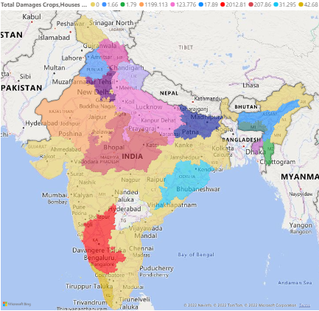 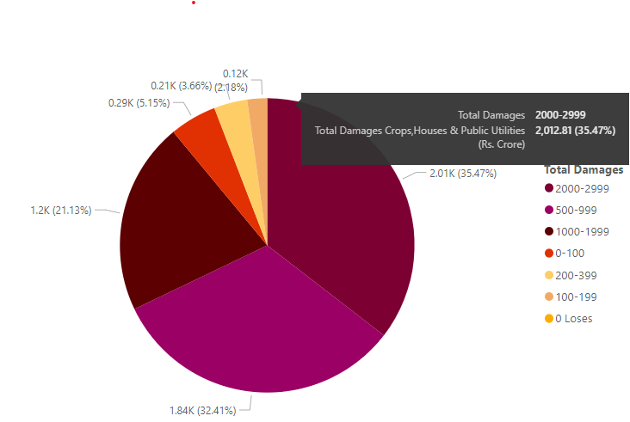

**2016 FLOOD DATA**

Rains created havoc for many regions starting from down South to the Western Coastal regions during the Southwest Monsoon. Most of the regions of Hyderabad and Karnataka faced an issue of heavy rainfall, out of which the most affected region/state was Karnataka. On **22nd September 2016** due to heavy rainfall and low pressure associated with cyclonic circulation, districts of Bidar, Kalburgi, and parts, of Raichur faced extremely heavy rainfall resulting in the overflowing of reservoirs leading to a critical situation. The irony of this whole situation is that while most of the North Karnataka belt faced an issue of Flood the South part of Karnataka faced an acute shortage of water leading to a Drought. Most of the roads and bridges were flooded with water making it impossible for rural areas to connect with the urban areas. National Disaster Response Force (NDRF) had to intervene when the situation was out of control. With estimated damage to crops and houses, the total loss incurred was roughly around **Rs.2012.81 crore** for the state of Karnataka. As we can see in the pie chart Karnataka’s total damage accounts for 35.47% of the total damage caused by the Flood throughout India.

**After the 2016 data, let’s have a look at how Flood affected 2017, was Karnataka the most affected state gain or is the scenario different?**

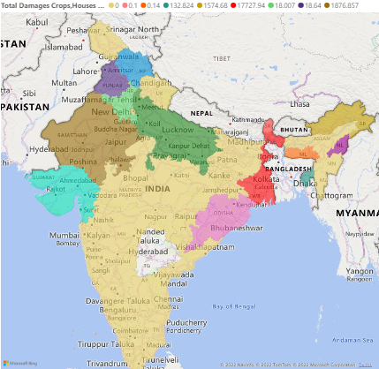 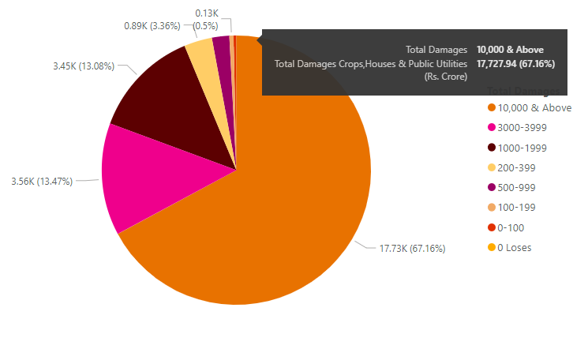

**2017 FLOOD DATA**

Amidst the Heavy rainfall during July-August 2017, the most affected state of all was West Bengal. Due to depression in the Bay of Bengal, heavy rains were witnessed in the last week of July leading to rising in the levels of reservoirs. Indian Metrologic Department (IMD) issued a warning stating that there might arise a situation for Flood, leading to which 14 districts in parts of West Bengal started to witness heavy rains. According to the officials, more than 200 human lives were lost and more than 20 lakh people were affected in over 160 villages across West Bengal. As we can see that West Bengal was the most hit state concerning the total damages to the crops, houses, and public utilities, a total of **Rs.17,727.94 crores** was lost to the damages. Apart from this, we can also see that West Bengal accounted for more than 50% of the total Flood Disaster with a whopping **67.16%** throughout India.

**Let us now move on to the final data for the year 2018.**

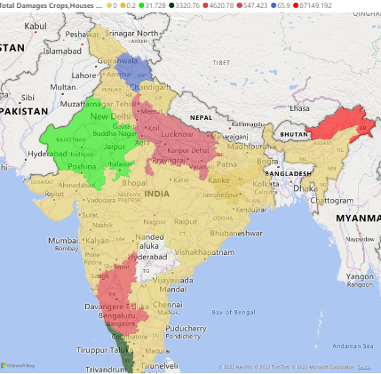 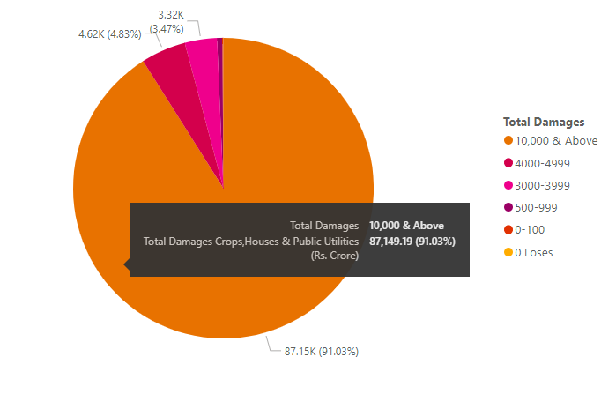

**2018 FLOOD DATA**

With sudden and heavy rainfall and the release of Dams due to Cloudbursts in the Northeast state of Arunachal Pradesh, the state witnessed Flash Floods and Landslides on **14th September 2018**. The flash flood disrupted water supply in many regions of the state, further adding to this many of the roads and bridges were washed out. Though less death was recorded, the damages that were accounted for were maximum for crops and public utilities. Around 22,689 people over 118 Villages in Arunachal Pradesh were affected in total, with a death toll of 33. The total estimated damage was around **Rs.87, 149.19 crores** for the state. According to the local officials, approximately **4,078 hectares** of Agricultural Land were submerged under water in a particular district. As we can see from the above pie chart Arunachal Pradesh alone accounted for **91.03%** of the total damages(in Rs. Crore) occurring across India.

* **How can this data be used by Insurers for their Risk Profiling?**

Insurers usually keep in my mind the risk associated with a Natural Disaster occurs, how the Natural Disaster is a threat to the organization and how can it be balanced so that there are no disruptions in the organization. There are some parameters that Insurers consider while Risk Profiling, they are

* Nature of the threat an organization faces
* Degree to which the threat can impact the organization
* Cost associated with the type of risk

The Flood database will help the insurers understand the information related to the flood such as where the flood had occurred, what was the intensity of the flood, how it affected public utilities and how many lives were lost. It also gives information on what was the total damage caused due to floods, how the weather pattern has changed in a particular region due to unknown factors and so on. With the help, of the above database, the Insurers can ensure that the following points are noted i.e.

* Reimagining Risk evaluation
* Improving Customer experience
* Enhance efficiency and decision-making throughout the underwriting process

Once all the points are accounted for, the role of the Insurance Company comes into the picture when they have to compensate the damaged assets, and help people recover their compensation. Once the Insurers are aware of the threat, they then can build their Risk profile based on the outcomes the datasets provide and analyze what are all the parameters they should consider before planning to act on the disaster that has occurred.

* **Conclusion**

To sum it up, it was seen how Insurers benefitted from the dataset provided by the Indian Government in Risk Profiling. We could also conclude that the Indian economy was badly affected due to the Natural Disasters – Flood and apart from that property damages were at their peak. We were also able to show insights into the dataset provided to us using powerful Data Visualization tools such as Power BI. It not only showcased the data but also provided in-depth detail for the insurers to better understand the event that has occurred therefore it can be concluded that data plays an important role in helping Insurers in their Risk Profiling.

* **Reference**

1. <https://www.ibtimes.co.in/india-most-flood-prone-country-world-report-658450#:~:text=Examining%20and%20quantifying%20the%20risk,Bangladesh%2C%20at%203.48%20million%20people>.
2. <https://data.gov.in/>
3. <https://www.indiatoday.in/india/story/karnataka-floods-drought-crop-failure-343069-2016-09-25>
4. <https://indianexpress.com/article/north-east-india/assam/flash-floods-in-assam-arunachal-pradesh-two-dead-thousands-affected-5356314/>
5. <https://floodlist.com/asia/india-floods-west-bengal-july-august-2017>